

**รายงาน**

**เรื่อง** Depth-limited search

**จัดทำโดย**

1. นาย ชาคริตขอนกระโทก 511733023409-4 CPE 6/3

2. นาย กุลธวัช อนันตภูมิ 511733023406-0 CPE 6/3

3. นาย จักรพงศ์ ศาลกลาง 511333023404-5 CPE 6/3

ส่ง

อ. ธรรมกร ครองไตรภพ

รายงานนี้เป็นส่วนหนึ่งของวิชา ARTIFICIAL INTELLIGENCE

ภาคเรียนที่ 2 ปีการศึกษา 2555

มหาวิทยาลัยเทคโนโลยีราชมงคล (อีสาน)

Depth-limited search

- เป็นวิธีการค้นหาแบบแนวลึกก่อนที่มีการกำหนดระดับให้แคบลง เพื่อแก้ปัญหาการเกิดในขณะค้นหา และช่วยลดเวลา การค้นหาของการค้นหาแบบ Depth-First Search

- Depth-limited search เพิ่มการระบุจำนวนชั้นที่ลงลึกในการค้นหา

แบบ Depth-Limited Searchการค้นหา

โจทย์ กำหนดให้โหนดE เป็นโหนดเป้าหมาย และจำกัดระดับค้นหาเท่ากับ 2

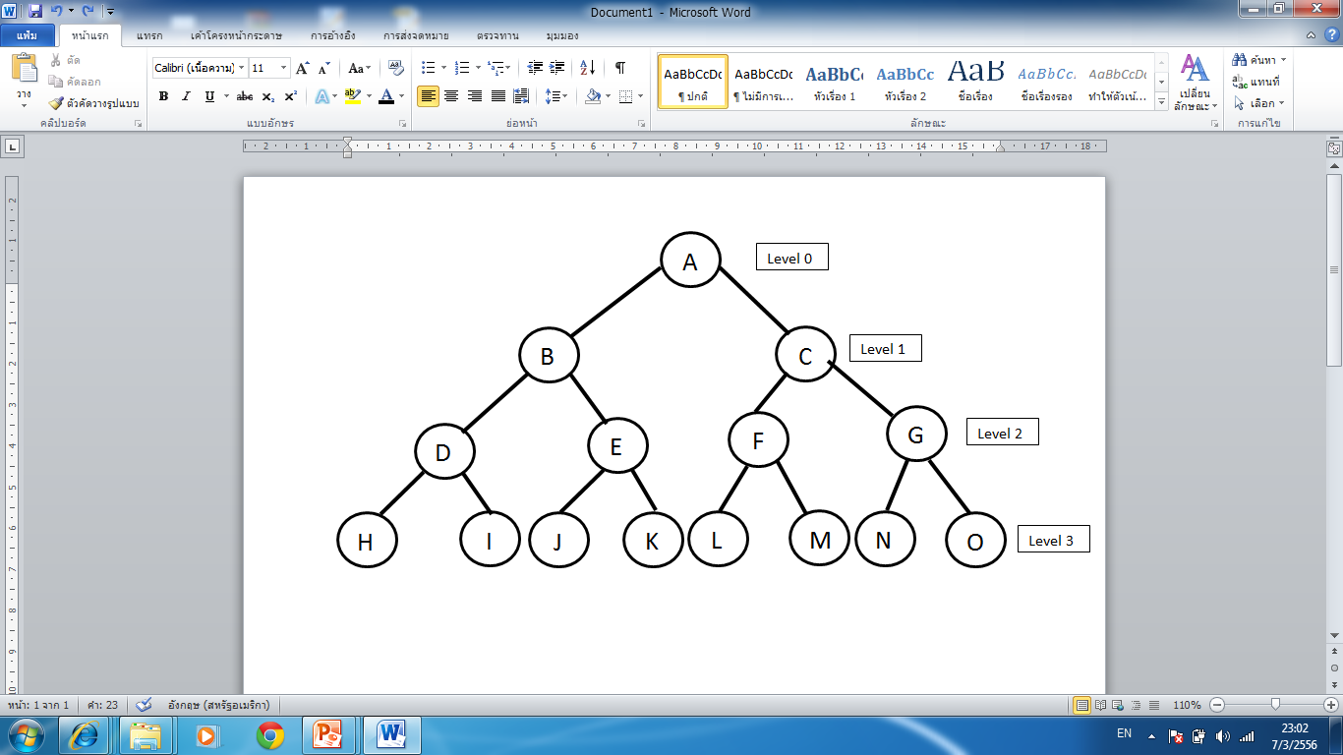

**ขั้นตอนการค้นหาแบบ Depth-Limited Search**

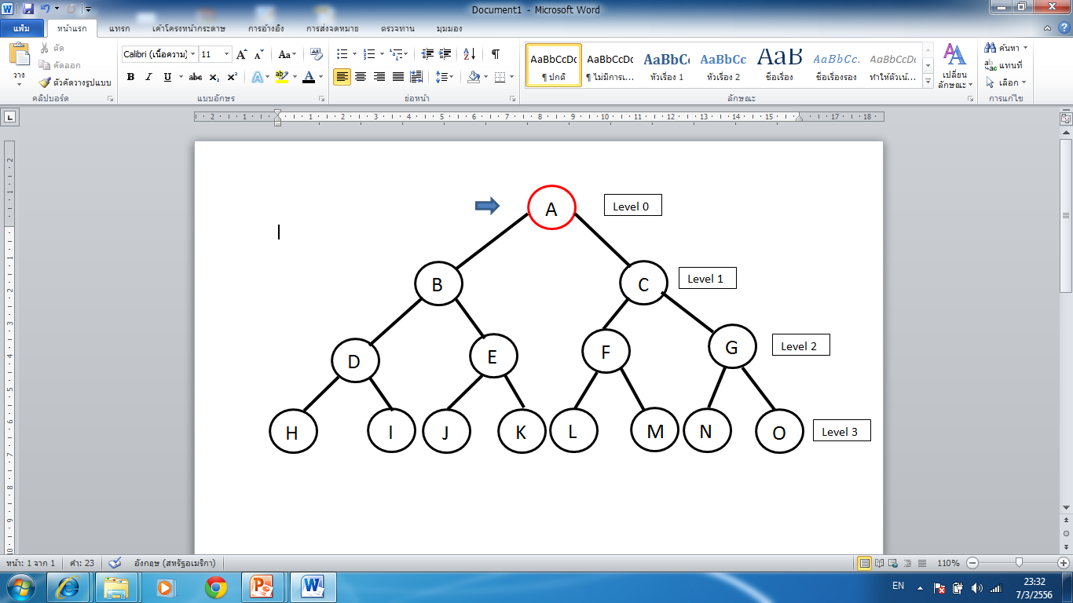

**ขั้นตอนที่ 1**

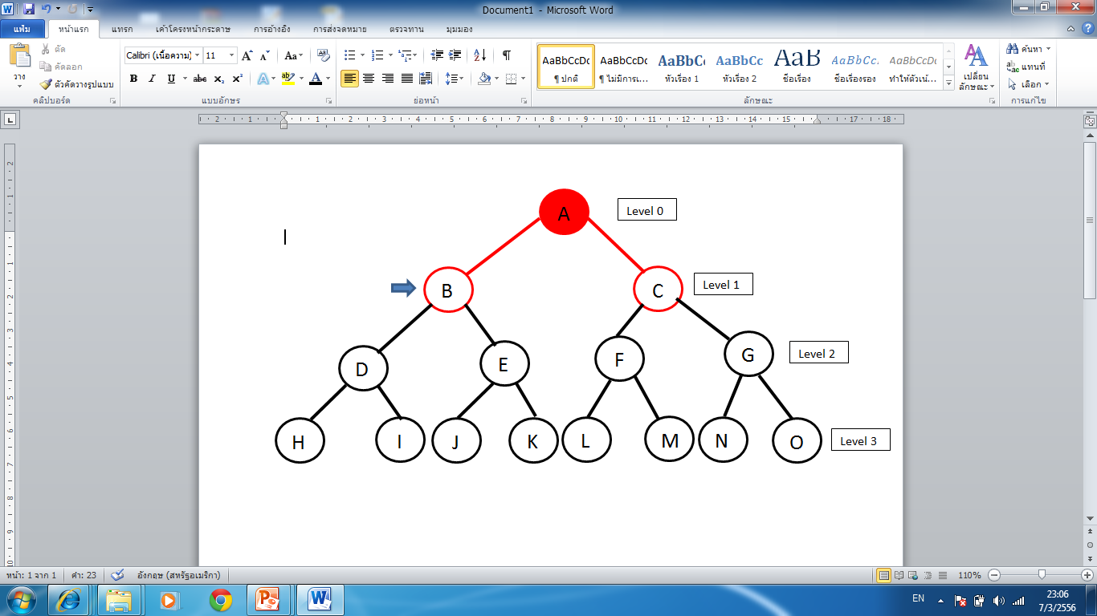

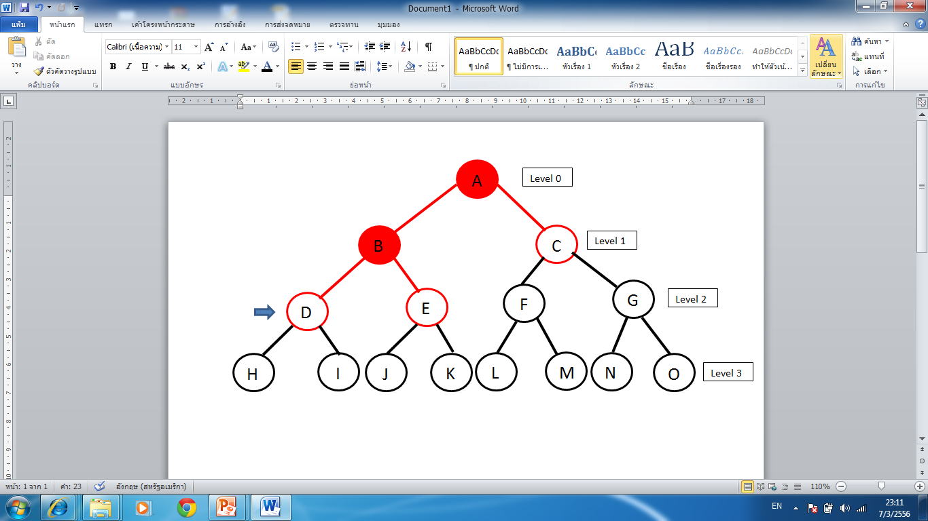**ขั้นตอนที่ 2**

**ขั้นตอนที่ 3**

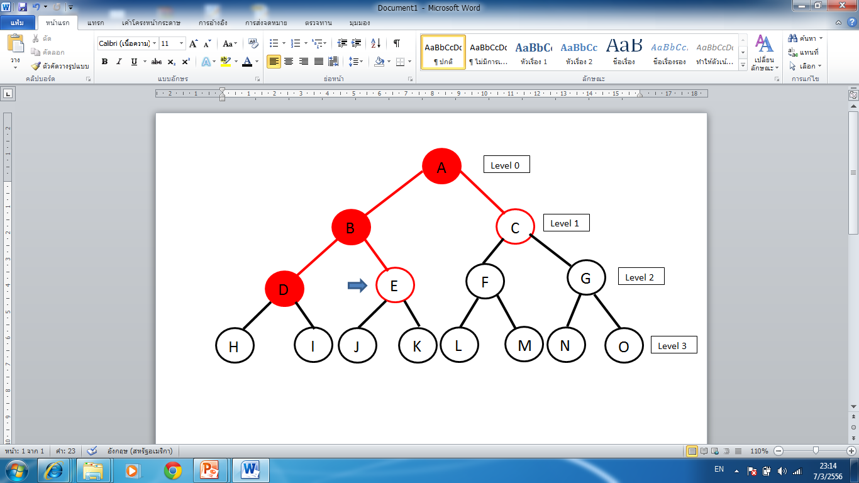

Flowchat

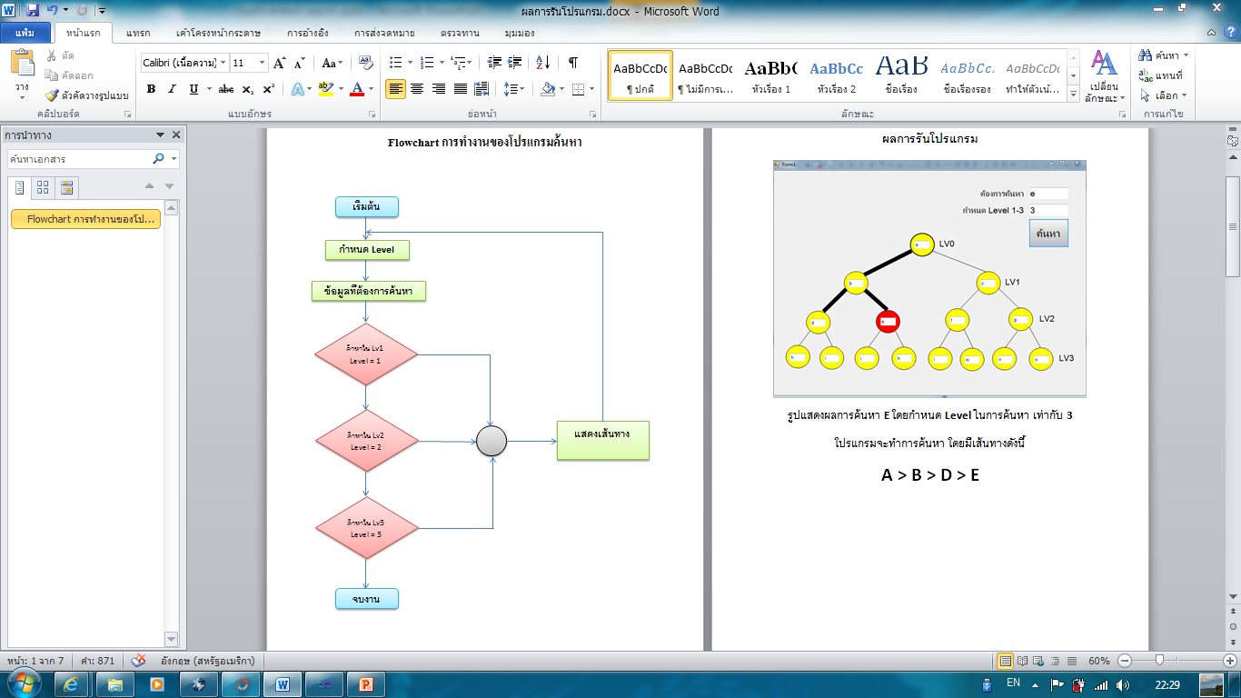

**ผลการรันโปรแกรม**

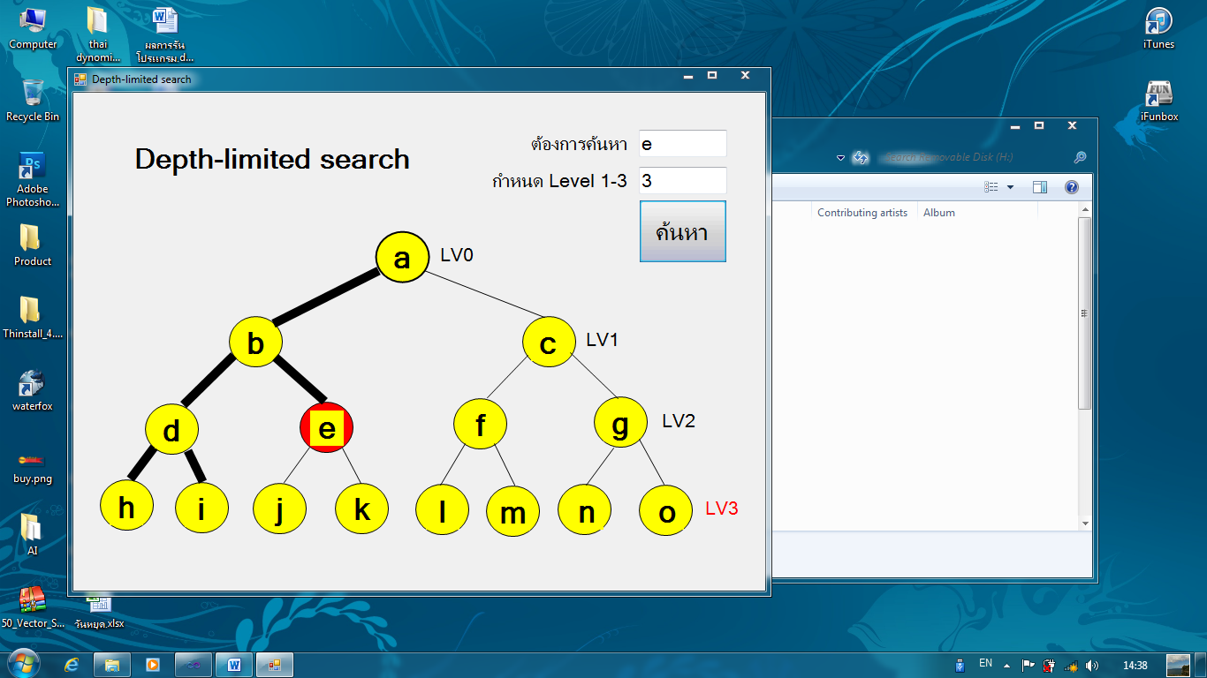

* รูปแสดงผลการค้นหา E โดยกำหนด Level ในการค้นหา เท่ากับ 3
* โปรแกรมจะทำการค้นหา โดยมีเส้นทางดังนี้
* A > B > D > E

**โค๊ดโปรแกรม**

Public Class Form1

Public line(20, 20) As String

Public count As Integer

Public le As Integer

Public jj As Boolean = 0

Private Sub Form1_Load(ByVal sender As System.Object, ByVal e As System.EventArgs) Handles MyBase.Load

line(0, 0) = TextBox3.Text

line(1, 0) = TextBox4.Text

line(1, 1) = TextBox5.Text

line(2, 0) = TextBox6.Text

line(2, 1) = TextBox7.Text

line(2, 2) = TextBox8.Text

line(2, 3) = TextBox9.Text

line(3, 0) = TextBox10.Text

line(3, 1) = TextBox11.Text

line(3, 2) = TextBox12.Text

line(3, 3) = TextBox13.Text

line(3, 4) = TextBox14.Text

line(3, 5) = TextBox15.Text

line(3, 6) = TextBox16.Text

line(3, 7) = TextBox17.Text

End Sub

Private Sub Search_Click(ByVal sender As System.Object, ByVal e As System.EventArgs) Handles Search.Click

OvalShape1.BackColor = Color.Yellow

OvalShape2.BackColor = Color.Yellow

OvalShape3.BackColor = Color.Yellow

OvalShape4.BackColor = Color.Yellow

OvalShape5.BackColor = Color.Yellow

OvalShape6.BackColor = Color.Yellow

OvalShape7.BackColor = Color.Yellow

OvalShape8.BackColor = Color.Yellow

OvalShape9.BackColor = Color.Yellow

OvalShape10.BackColor = Color.Yellow

OvalShape11.BackColor = Color.Yellow

OvalShape12.BackColor = Color.Yellow

OvalShape13.BackColor = Color.Yellow

OvalShape14.BackColor = Color.Yellow

OvalShape15.BackColor = Color.Yellow

LineShape1.BorderWidth = 1

LineShape2.BorderWidth = 1

LineShape3.BorderWidth = 1

LineShape4.BorderWidth = 1

LineShape5.BorderWidth = 1

LineShape6.BorderWidth = 1

LineShape7.BorderWidth = 1

LineShape8.BorderWidth = 1

LineShape9.BorderWidth = 1

LineShape10.BorderWidth = 1

LineShape11.BorderWidth = 1

LineShape12.BorderWidth = 1

LineShape13.BorderWidth = 1

LineShape14.BorderWidth = 1

le = CInt(level.Text)

' Label1.Text = le

If le = 0 Then

End If

If le = 1 Then

Label4.ForeColor = Color.Red

If line(1, 0) = total.Text Then

LineShape1.BorderWidth = 10

OvalShape2.BackColor = Color.Red

jj = 1

End If

If line(1, 1) = total.Text Then

LineShape1.BorderWidth = 10

LineShape8.BorderWidth = 10

OvalShape3.BackColor = Color.Red

jj = 1

End If

ElseIf le = 2 Then

Label5.ForeColor = Color.Red

If line(1, 0) = total.Text Then

LineShape1.BorderWidth = 10

OvalShape2.BackColor = Color.Red

jj = 1

End If

If line(1, 1) = total.Text Then

LineShape1.BorderWidth = 10

LineShape8.BorderWidth = 10

LineShape2.BorderWidth = 10

LineShape3.BorderWidth = 10

OvalShape3.BackColor = Color.Red

jj = 1

End If

If line(2, 0) = total.Text Then

LineShape1.BorderWidth = 10

LineShape2.BorderWidth = 10

OvalShape4.BackColor = Color.Red

jj = 1

End If

If line(2, 1) = total.Text Then

LineShape1.BorderWidth = 10

LineShape2.BorderWidth = 10

LineShape3.BorderWidth = 10

OvalShape5.BackColor = Color.Red

jj = 1

End If

If line(2, 2) = total.Text Then

LineShape1.BorderWidth = 10

LineShape2.BorderWidth = 10

LineShape3.BorderWidth = 10

LineShape8.BorderWidth = 10

LineShape9.BorderWidth = 10

OvalShape6.BackColor = Color.Red

jj = 1

End If

If line(2, 3) = total.Text Then

LineShape1.BorderWidth = 10

LineShape2.BorderWidth = 10

LineShape3.BorderWidth = 10

LineShape8.BorderWidth = 10

LineShape9.BorderWidth = 10

LineShape10.BorderWidth = 10

OvalShape7.BackColor = Color.Red

jj = 1

End If

ElseIf le = 3 Then

Label6.ForeColor = Color.Red

If line(1, 0) = total.Text Then

LineShape1.BorderWidth = 10

OvalShape2.BackColor = Color.Red

jj = 1

End If

If line(1, 1) = total.Text Then

LineShape1.BorderWidth = 10

LineShape8.BorderWidth = 10

LineShape2.BorderWidth = 10

LineShape3.BorderWidth = 10

LineShape4.BorderWidth = 10

LineShape5.BorderWidth = 10

LineShape6.BorderWidth = 10

LineShape7.BorderWidth = 10

OvalShape3.BackColor = Color.Red

jj = 1

End If

If line(2, 0) = total.Text Then

LineShape1.BorderWidth = 10

LineShape2.BorderWidth = 10

OvalShape4.BackColor = Color.Red

jj = 1

End If

If line(2, 1) = total.Text Then

LineShape1.BorderWidth = 10

LineShape2.BorderWidth = 10

LineShape3.BorderWidth = 10

LineShape4.BorderWidth = 10

LineShape5.BorderWidth = 10

OvalShape5.BackColor = Color.Red

jj = 1

End If

If line(2, 2) = total.Text Then

LineShape1.BorderWidth = 10

LineShape2.BorderWidth = 10

LineShape3.BorderWidth = 10

LineShape8.BorderWidth = 10

LineShape9.BorderWidth = 10

LineShape4.BorderWidth = 10

LineShape5.BorderWidth = 10

LineShape6.BorderWidth = 10

LineShape7.BorderWidth = 10

OvalShape6.BackColor = Color.Red

jj = 1

End If

If line(2, 3) = total.Text Then

LineShape1.BorderWidth = 10

LineShape2.BorderWidth = 10

LineShape3.BorderWidth = 10

LineShape8.BorderWidth = 10

LineShape9.BorderWidth = 10

LineShape10.BorderWidth = 10

LineShape4.BorderWidth = 10

LineShape5.BorderWidth = 10

LineShape6.BorderWidth = 10

LineShape7.BorderWidth = 10

LineShape11.BorderWidth = 10

LineShape12.BorderWidth = 10

OvalShape7.BackColor = Color.Red

jj = 1

End If

If line(3, 0) = total.Text Then

LineShape1.BorderWidth = 10

LineShape2.BorderWidth = 10

LineShape4.BorderWidth = 10

OvalShape8.BackColor = Color.Red

jj = 1

End If

If line(3, 1) = total.Text Then

LineShape1.BorderWidth = 10

LineShape2.BorderWidth = 10

LineShape4.BorderWidth = 10

LineShape5.BorderWidth = 10

OvalShape9.BackColor = Color.Red

jj = 1

End If

If line(3, 2) = total.Text Then

LineShape1.BorderWidth = 10

LineShape2.BorderWidth = 10

LineShape4.BorderWidth = 10

LineShape5.BorderWidth = 10

LineShape3.BorderWidth = 10

LineShape6.BorderWidth = 10

OvalShape10.BackColor = Color.Red

jj = 1

End If

If line(3, 3) = total.Text Then

LineShape1.BorderWidth = 10

LineShape2.BorderWidth = 10

LineShape4.BorderWidth = 10

LineShape5.BorderWidth = 10

LineShape3.BorderWidth = 10

LineShape6.BorderWidth = 10

LineShape7.BorderWidth = 10

OvalShape11.BackColor = Color.Red

jj = 1

End If

If line(3, 4) = total.Text Then

LineShape1.BorderWidth = 10

LineShape2.BorderWidth = 10

LineShape4.BorderWidth = 10

LineShape5.BorderWidth = 10

LineShape3.BorderWidth = 10

LineShape6.BorderWidth = 10

LineShape7.BorderWidth = 10

LineShape8.BorderWidth = 10

LineShape9.BorderWidth = 10

LineShape11.BorderWidth = 10

OvalShape12.BackColor = Color.Red

jj = 1

End If

If line(3, 5) = total.Text Then

LineShape1.BorderWidth = 10

LineShape2.BorderWidth = 10

LineShape4.BorderWidth = 10

LineShape5.BorderWidth = 10

LineShape3.BorderWidth = 10

LineShape6.BorderWidth = 10

LineShape7.BorderWidth = 10

LineShape8.BorderWidth = 10

LineShape9.BorderWidth = 10

LineShape11.BorderWidth = 10

LineShape12.BorderWidth = 10

OvalShape13.BackColor = Color.Red

jj = 1

End If

If line(3, 6) = total.Text Then

LineShape1.BorderWidth = 10

LineShape2.BorderWidth = 10

LineShape4.BorderWidth = 10

LineShape5.BorderWidth = 10

LineShape3.BorderWidth = 10

LineShape6.BorderWidth = 10

LineShape7.BorderWidth = 10

LineShape8.BorderWidth = 10

LineShape9.BorderWidth = 10

LineShape11.BorderWidth = 10

LineShape12.BorderWidth = 10

LineShape10.BorderWidth = 10

LineShape13.BorderWidth = 10

OvalShape14.BackColor = Color.Red

jj = 1

End If

If line(3, 7) = total.Text Then

LineShape1.BorderWidth = 10

LineShape2.BorderWidth = 10

LineShape4.BorderWidth = 10

LineShape5.BorderWidth = 10

LineShape3.BorderWidth = 10

LineShape6.BorderWidth = 10

LineShape7.BorderWidth = 10

LineShape8.BorderWidth = 10

LineShape9.BorderWidth = 10

LineShape11.BorderWidth = 10

LineShape12.BorderWidth = 10

LineShape10.BorderWidth = 10

LineShape13.BorderWidth = 10

LineShape14.BorderWidth = 10

OvalShape15.BackColor = Color.Red

jj = 1

End If

End If

If jj = 0 Then

If le = 1 Then

LineShape1.BorderWidth = 10

LineShape8.BorderWidth = 10

End If

If le = 2 Then

LineShape1.BorderWidth = 10

LineShape8.BorderWidth = 10

LineShape2.BorderWidth = 10

LineShape3.BorderWidth = 10

LineShape9.BorderWidth = 10

LineShape10.BorderWidth = 10

End If

If le = 3 Then

LineShape1.BorderWidth = 10

LineShape8.BorderWidth = 10

LineShape2.BorderWidth = 10

LineShape3.BorderWidth = 10

LineShape9.BorderWidth = 10

LineShape10.BorderWidth = 10

LineShape4.BorderWidth = 10

LineShape5.BorderWidth = 10

LineShape6.BorderWidth = 10

LineShape7.BorderWidth = 10

LineShape11.BorderWidth = 10

LineShape12.BorderWidth = 10

LineShape13.BorderWidth = 10

LineShape14.BorderWidth = 10

End If

MsgBox("ไม่พบข้อมูล")

End If

jj = 0

End Sub

End Class